**Curriculum Vitae**

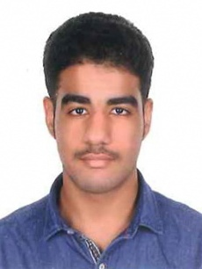Name : **Abdulla Ali Abdulla Ahmed Abdulla**

Nationality : Bahraini

CPR No : 010909842

Date of Birth : 24/09/2001

Marital Status : Single

Contact No : **38195261, 33079709**

Address : House 823, Road 6426, Blaock 364, Biladd Al Kadheem

Email : [abdullahaali257@gmail.com](mailto:abdullahaali257@gmail.com)

**Objective:**

To strive for a challenging job in a progressive organization, where I can contribute and build my professional carrier along with the growth of organization and to give the best of my qualification, experience and abilities.

**Educational Qualification:**

* Secondary School

**Skills:**

* Ability to work under pressure
* Clam and effective communicator
* Serious and faithful in work
* Good communication skill
* Good Photography Skills

**Computer Knowledge:**

* Computer Basic Knowledge

**Language:**

* English and Arabic